Newtowngore NS

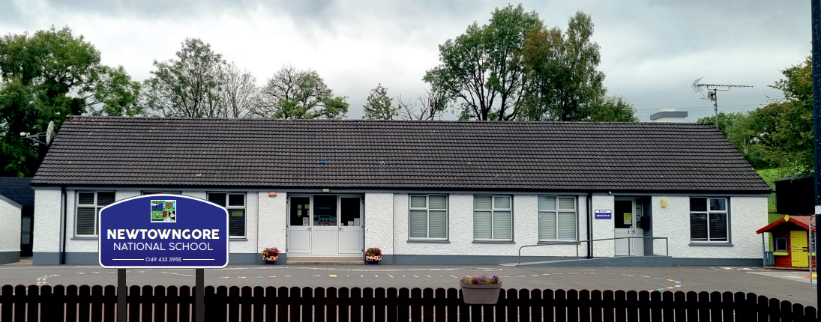

Information Booklet

Page 3
- Welcome Note from Principal
- School Personnel
- School Contact Details
Page 4
- School Hours
- Board of Management
- Ethos
Page 5
- About the School
- School Uniform
- Parents’ Association
Page 6
- School Communication
- Curriculum
- Book Rental
Page 7
- Extra Curriculum Activities
- Junior Infant Induction Day
Page 8
- Homework
- Additional Education Needs
- Code of Behaviour
Page 9
- Bullying
- Healthy Lunch
- School Attendance
- School Transport
Page 10
- Pupil Personal Accident Insurance
- Health and Safety
- Allergies/Administration of Medicine
- Accidents in School
Page 11
- ‘Parents Are Teachers Too’

Welcome note from the Principal
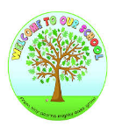
Welcome to Newtowngore National School. This booklet provides information for parents and pupils who are enrolling in the school for the first time. While the largest group of new enrolments in any year is the new Junior Infant class, we also welcome new pupils to the older classes and have kept this in mind in preparing the information. Hopefully many of your questions will be answered by careful reading of this booklet. If you have any further queries, please feel free to contact me via the school email or landline.
We hope that each child will enjoy their period in our school; and that it may prove to be a stimulating, happy and productive time in their lives.
Le gach dea-ghuí
Zena Anderson
Principal

School Personnel
Principal: Mrs. Zena Anderson
Deputy Principal: Ms. Niamh Farrell

There are 2 Class Teachers, 2 Special Education Teacher and 1 EAL Teacher
Junior & Senior Infants, 1st and 2nd Class: Ms. Niamh Farrell

3rd, 4th, 5th & 6th Class: Mrs. Zena Anderson
Shared Special Education Teacher: Mrs. Sharon O’Neill Chambers/ Mrs. Susan Smith
Principal Release Cluster Teacher: Ms. Eve Gorman
EAL Teacher: Ms. Aisling Kells
Special Needs Assistant: Mrs. Geraldine Murphy
School Inspector: Inspector Yvonne Ní Mhurchú
School Secretary: Mrs Caroline Comiskey

School Contact Details
Address: Newtowngore National School, Newtowngore, Co. Leitrim, N41 RY65.
Phone No: 049 4333955
E-mail: newtowngorenatschool@gmail.com
School website: www.newtowngorens.ie
Facebook page: Newtowngore N.S.

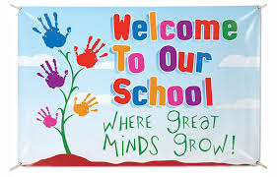


School Hours
9.10am School Day begins
10.50am-11.05am Break
12.20pm – 12.50pm Lunch
1.50pm JI & SI school day ends
2.50pm 1st-6th Class school day ends
Parents are reminded that the Board of Management of the school does not accept responsibility for pupils before the official opening time of 9.10a.m., or after the official closing time of 2.50p.m.
Drumreilly Community Afterschool is also available for children in our school. Drumreilly Afterschool provide their services onsite from 1.50-2.50pm for the Junior and Senior Infants (Please see School Transport p9)
Board of Management
The Board of Management has legal responsibility for the overall running of the school. It serves a term of four years. The current Board was formed in December 2023. A new Board will be elected in November 2027. We are grateful to all members of the board for giving their time and energy voluntarily to support the school.
Principal: Mrs. Zena Anderson

Teacher’s Representative: Mrs. Sharon O’Neill Chambers
Parents’ Representative: Mr. Carl Johnston (Chairperson)
Mrs. Helen Parke
Patron’s Representative: Rev. Richard Waller
Mrs. Miriam Fisher
Community Representatives: Mrs. Florence Bayliss (Treasurer)
Mrs. Anne Garland
Ethos

Newtowngore National School is a co-educational primary school with a Church of Ireland ethos under the patronage of the Church of Ireland Bishop of Kilmore, Elphin and Ardagh. The school warmly welcomes and gives due recognition to children of all other religious beliefs and none.
Diversity is cherished, with a spirit of mutual respect for all. We recognise and foster the unity of mind, body and spirit in a holistic approach to ensure that every child in our care is treated fairly, equally and respectfully. We endeavour to enhance the self-esteem of everyone in the school community and encourage pupils to be responsible and to have respect for people and property.
The Religious Education programme of our school enables the child to develop spiritual and moral values to come to a knowledge of God.
About the school
Newtowngore National School is a warm, welcoming and inclusive school where children are educated in a safe, happy and caring atmosphere. We are a small, rural, two-teacher school, situated in a splendid setting on the Newtowngore/Carrigallen road. Our lower pupil-teacher ratio means that all children receive small-group attention throughout their schooling. We are fortunate to have a long-standing and proud tradition of community support for our school.
We have a committed and dedicated staff who believe in creating a supportive, fun and active learning environment; where each child’s unique character and abilities are recognised, developed and celebrated. We are committed to excellence in teaching and learning which encourages each child to achieve his/her full potential. We are very aware you entrust your most precious possession to us, your child, and in our daily work our aim is to offer a rich and broad curriculum where the emphasis is placed on “trying your best”, and learning to be “comfortable with yourself”. It is our hope that in doing so, we will assist in developing the foundation for your child to become a happy, well-rounded, confident, self-motivated, socially responsible person, that will contribute positively in their own way to our community and society.
Our school is well maintained and in recent years our school building and playground facilities have been developed and upgraded. This helps to create a bright, energetic and stimulating environment in which the children learn and interact with care and confidence. Our spacious classrooms are well resourced and are equipped with interactive whiteboard panels. We also have a suite of 18 iPads allowing pupils a chance to develop ICT skills. We have a spacious playground including a large grass area and an outdoor adventure trail, to promote pupils’ balance and co-ordination.

School Uniform
All pupils wear the school uniform for all school occasions everyday (school tours being an exception).
- Navy jumper

- Blue Polo shirt
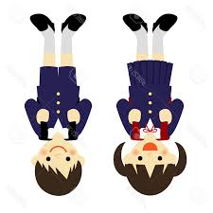
- Plain Navy trousers (no logos/stripes/lines)
- Girls may wear a skirt/pinafore with plain navy tights
- Navy shorts/skort can be worn in summer but must be with the polo shirt
Shoes – None specified but PLEASE ensure they are clean and well-maintained. Velcro is recommended for children that require assistance with shoe laces. All shoes should be suitable for the weather conditions and activities that are a routine part of the school day such as being in the yard playing games.
Jewellery: Stud earrings in the lobe of the ear and watches are permitted jewellery.
Label: All Jumpers, coats, bags, footwear, school requisites, playing gear must be clearly labelled with pupil’s name so that mislaid items can easily be recovered. Many children possess similar items and this avoids any confusion and minimises loss of personal belongings.
Parents’ Association
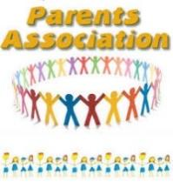
Newtowngore N.S. has an active Parents’ Association, where all parents have an opportunity to get involved. We welcome parental involvement in policy formation, fundraising and school celebrations and events throughout the year. The Parents’ Association support staff in organising school activities and are actively involved whenever requested by The Board of Management or School Staff.
School Communication
We are very aware we live in a more rushed world but actively encourage parents to be involved in their child’s education. Our aim is to foster positive pathways for communication between the school and parents. In doing so, we hope to facilitate discussion in relation to your child’s progress and relevant school information /events. In order to facilitate this, we use a number of methods of communication including:
- School Homework Diary/Homework Sheet (please check routinely)

- Phone calls/E-mails
- Letters/Newsletters
- Parent-Teacher meetings (Oct/Nov)
- End of Year Reports
Should you wish to meet your child’s teacher on a matter that concerns you please do contact the school by phone or email. The teacher/principal will return your call at a later time or arrange a meeting at a mutually agreeable time if necessary. All parents are requested not to contact teachers on their personal mobile phones. All school related queries must go through the school office (049) 4333955 or email newtowngorenatschool@gmail.com.
Alternatively, you can write a note in your child’s diary to inform the teacher if you are picking up your child early /reason for an absence / homework was unable to be completed due to an appointment.........

Curriculum
The primary curriculum at Newtowngore National School aims to provide a broad learning experience and encourages a rich variety of approaches to teaching and learning that cater for the different needs of individual children.
The curriculum is divided into the following key areas incorporating 12 subjects:
- Languages – Irish and English;
- Mathematics;
- Social, Environment and Scientific Education (History, Geography & Science);
- Arts Education, including Visual Arts, Music and Drama;
- Physical Education; and
- Social, Personal and Health Education (incorporating Relationships and Sexuality Education R.S.E. and the personal safety skills programme Stay Safe)
- Religious Education
Further information on the primary curriculum can be found at the Department of Education and Skills website.
Book Rental
The school operates a book rental scheme. The school purchases all books, workbooks, copies/homework diary. They are made available to the pupils on their return to school in September. Parents are asked to cover and label all books, copies, workbooks to keep them in good condition. All books not written into are on loan from the school for a rental fee and copies/workbooks written into are also supplied by the school, at cost price.

Extra-Curricular Activities


In Newtowngore N.S. we avail of opportunities to expose pupils to a variety of experiences and initiatives in addition to the formal curriculum. We strive to nurture the child in all dimensions of his / her life — spiritual, moral, cognitive, emotional, imaginative, aesthetic, social and physical. We endeavour to recognise and foster each child’s individual talents. Some children are very able readers, some excellent mathematicians, more are fine artists or singers or sports people. We try to give them at least a "taste" of extra-curricular activities while they are here, so they experience success and enjoyment, develop a sense of teamwork, an interest for their future and hopefully build their self-esteem along the way.
Newtowngore NS is an active school and physical activity is encouraged and promoted. A wide range of sports and movement skills are taught during P.E. lessons. External coaches visit the school, and the children partake in sporting leagues and matches against other schools.
Through the cooperation of pupils and staff, we have attained Green Flag status. As part of this initiative pupils are encouraged to reduce waste, recycle and conserve energy and water. Waste separation is practiced in all classrooms.
Other activities include:
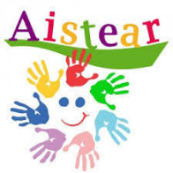
- School concerts and shows
- Cumann na mBuncol
- AISTEAR
- Buddy Reading between the children in the Junior and Senior Classrooms
- Visiting Speakers to the school, including poets/artists/ wild-life experts, historians
- Junior Entrepreneur Programme
- Local nature walks
- Discover Primary Science and Maths

- Participating in Art Competitions
- Chess
- ICT Education- Coding, Microbits, Lego Spike, Beebots, Bluebots
- Educational trips during the school year
- Music Generation Programme
- Health Promoting School Initiative
- Credit Union Quiz
- Peace IV Programme
- Bicycle safety workshops and lessons
- S.T.E.M – Science, Technology, Engineering and Mathematics
- BLAST- Artist in Residence
- Amber Flag
- STEPS Engineering
- Children participate in Maths Week, Science Week, Engineering Week, Seachtain na Gaeilge, World Book Day and many other projects and initiatives
Junior Infant Induction Day
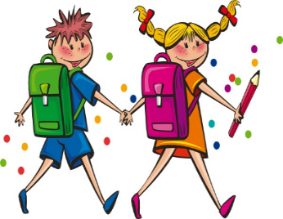
In June, all new Junior Infants are invited to attend the school for an induction day. This induction day gives the children the opportunity to meet with their new teacher and to also meet the other children who will be in their class. On this morning, the children will complete some activities in the classroom and will get to experience one break-time. In the subsequent weeks following your child’s first day at school in September, parents will be invited to an information meeting with the class teacher.
Homework
Homework fosters independence, self-reliance, responsibility and lifelong learning. In general, homework should be achievable by a child working on their own to the best of their ability. It is normally prepared by the teacher in class. It can be used to practise what is done in school or can be designed to challenge children’s ability and provide opportunities for creativity.
How Can Parents Help:
You can help by providing a quiet place to work, by listening to reading, by asking spellings and tables, and by giving help where needed. Please feel free to correct work where necessary. Please ensure your child's homework is completed and presented as well as they are able, and sign their homework diary/ sheet accordingly. It is especially important as your child progresses through primary school to check homework as future study patterns are set in these years. The homework diary is a good way to communicate with your child's teacher so feel free to use it to send notes and messages.
Approximate time that children will need to spend on homework:
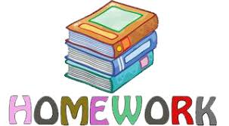
Infants: 20 mins
1st & 2nd Class: 20 – 30 mins
3rd & 4th Class: 30 -40 mins
5th & 6th Class: 40-50 mins

Additional Educational Needs
All children are valued, respected and welcomed to the school whatever their additional need. We will support their learning and ensure they are fully included in school activities, while also helping these pupils to attain maximum educational achievement while in our school.
Pupils will be selected for supplementary teaching in accordance with DES guidelines, which are outlined in our Special Educational Needs Policy. This selection process will follow administration, scoring and interpretation of standardised screening tests. Emphasis will be placed on early intervention and prevention programmes. Pupils will be monitored and have their learning targets reviewed on an on-going basis. The results of these will be communicated to parents regularly. Teacher assessments may be carried out on pupils who have been identified as experiencing low achievement or learning difficulties and referral to outside agencies may be made.

Should your child require any special assistance, be it short term or long, a member of staff will contact you and invite you to the school to discuss your child’s needs. The school also has the services of an educational psychologist, who works closely with the school in assessing children who may be experiencing difficulties.
Code of Behaviour
All parents receive the school’s Code of Behaviour on application. Newtowngore NS places great importance on pupils being encouraged to develop good patterns of behaviour. The school rules must be adhered to at school and at all school related events.

Bullying

Bullying in any form, verbal or physical is totally unacceptable and runs contrary to the stated aims of respect, courtesy and consideration. The Bí Cineálta Policy drawn up by the staff in collaboration with parents and approved by the Board of Management operates in the school. A copy of this policy is available on our website.
It is essential that anyone (staff member, pupil or parent) who suspects that bullying is occurring informs the school authorities immediately. All reports and information received will be acted on with discretion and sensitivity. At all times staff foster a positive atmosphere of inclusiveness and integration to ensure that all children develop a positive attitude towards each other.

Healthy Lunch

The school operates a Healthy Eating Policy. Please follow our Healthy Eating Policy and ensure that children are given food that you know that they will eat. In the interest of pupils’ health and in fairness to other pupils, all parents are expected to abide by this policy. Pupils are expected to bring a lunch, generally accepted as “healthy,” i.e. sandwiches, fruit, yoghurts etc. Pupils are asked to bring either water or milk to school every day. Crisps, chewing gum, fizzy drinks and lollipops are not allowed in school. Once a week, on a Friday, children are permitted to bring in one small treat. The school’s Healthy Eating Policy is available on our website. Please ensure that your child's lunch box and drinks bottle are clearly labelled with your child's name.
Hot Meals
The school participates in the Hot Meals Programme for schools. Thanks to this government scheme every child gets a hot school meal free of charge every day. These meals are supplied by Fresh Today. Parents/Guardians choose and order their child’s daily hot meal on the Fresh Today app which provides a wide variety of food options to suit every child’s needs.
School Attendance
Under the Education Welfare Act (2000) you must ensure that your child attends school regularly. If your child is absent from school for any reason you must notify the school of the reason for the absence in writing or by phone. The school must inform the National Education Welfare Board when a pupil is absent for 20 days or more in a school year. Taking children on holidays during the school term is not encouraged.

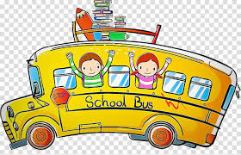
School Transport
Our school bus collects children from a wide catchment area.
School transport is available if you are on a bus route and over a distance of 3.2 kilometres from the school. The School Transport Department of Bus Eireann determines if your child/children are eligible. If you wish to apply for school transport, contact the Dundalk School Transport Office: 042 6825900. Children can also access Drumreilly Afterschool Facility by applying for a concessionary ticket on the Bus Éireann website. On-site afterschool care for children in the infant classes is available from 1:50 to 2:50.

Pupil Personal Accident Insurance
The Board of Management purchases 24 Hour Personal Accident Insurance for all pupils in the school. It insures the pupil against medical or dental expenses up to €50,000. As we have opted for 24 Hour Cover even if a pupil has an accident outside school hours they are still insured.

Health and Safety
As part of our school health programme we encourage regular washing of hands, particularly after toilet use. We are not, however, always able to oversee this so please remind your child of its importance. Unfortunately, germs and viruses spread very quickly in a classroom environment so it is vital that the children are encouraged to use a tissue when blowing their nose and to cover their mouths and turn away when coughing.
If your child develops any infectious illness such as chickenpox please keep him/her away from school until the period of contagion is over and inform his/her teacher immediately.
We recommend that you check your child regularly for lice, treat immediately if they occur and inform the teacher so that notification of possible risk may be sent to other parents.
When the class teacher feels that a child is not well enough for school either as a result of becoming sick or an accident the Parents/Guardians will be contacted immediately.

Allergies/Administration of Medicines

The Board of Management requests parents to ensure that staff members are made aware in writing, of any medical condition suffered by their child. This information should be provided at enrolment or at the development of any medical conditions at a later date. As a general rule teachers will not be involved in the administration of medication.
Where children are suffering from life threatening conditions or allergies, or when pupils require the administration of medicine in school, parents must complete a Medication Administration Form and Administration of Medicines in Schools Indemnity Form (please contact the school secretary for these forms).

Accidents in School

If an accident happens in school, your child will receive first aid for minor cuts and bruises. If there is anything more serious you will be contacted. It is very important that we have a contact number of somebody who will be able to collect the child if the parent/guardian is not available. Parents are asked to make sure that the emergency phone number entered on their child’s Enrolment Form is up to date

PARENTS ARE TEACHERS TOO
I dreamed I stood in a studio,
And watched two sculptors there,
The clay they had was a young child’s mind
And they fashioned it with care.

One was a teacher, the tools he used
Were books and music and art;
One was a parent, with a guiding hand
And a gentle, loving heart.

Day after day the teacher toiled
With touch that was deft and sure,
While the parent, laboured by his side
And polished and smoothed it o’er.

And when at last their task was done,
They were proud that what they had wrought,
Could neither be, sold or bought.

And each agreed they would have failed
If they had worked alone,
For behind the parent stood THE SCHOOL,
And behind the teacher THE HOME.



Notes

